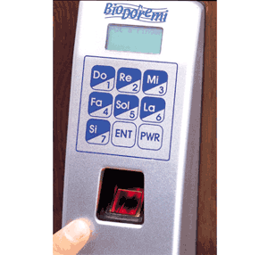

Department of Embedded System
CETPA INFOTECH PVT. LTD

CONTENT

- Introduction

2. Component Used

3. Circuit Diagram

4. 8051 Microcontroller Architecture

5. optocoupler

6. LCD

7. Stepper Motor

8. Diode

- Resistor

10. Crystal Oscillator

11. Voltage Regulator

12. Capacitor

13. Momentary switch

14. Source Code in Assembly

15. Bibliography

INTRODUCTION

The microcontroller based Door locker is an access control system that allows only authorized persons to access a restricted area. The system is fully controlled by the 8 bit microcontroller AT89C2051 which has a 2Kbytes of ROM for the program memory. The password is stored in the EPROM so that we can change it at any time.

The system has a Keypad by which the password can be entered through it. When the entered password equals with the password stored in the memory then the gate gets open. If we entered a wrong password then the Alarm is switched on.
This system is best suitable for corporate offices, ATMs and home security.

Features :
- Easy to use for day to day operation.
- LCD display
- Needs to be programmed only once.
- Easy to program.
- Previous and current password is stored in EEPROM

Benefits :
- Accuracy
- No manual intervention
- Saves man power and money
- Easy programming with the help of manual.

COMPONENTS USED

Sr. no. | Component used | Quantity (no.s)
1. | 89c51 microcontroller (base + IC) | 1
2. | Diode (4007, .7v) | 4
3. | Uln 2003 (base + IC) | 1
4. | bipolar Stepper motor | 1
5. | 1k resistance and 10k respectively | 6,1
6. | 47k resistance | 3
7. | 470 ohms resistance | 3
8. | 220 ohms resistance | 4
9. | Crystal oscillator(12mhz) | 1
10. | Transformer (220v-909) | 1
11. | L.E.D.s | 3
12. | Ceramic Capacitor (30pf-33pf) | 2
13. | Electrolytic capacitor (150uf,470 uf,10uf) | 1,1,1
14. | 40pin and 16pin ic base | 1,1
15. | Voltage regulator (7805)(+5v) | 1
16. | 16pin female connector(both side) | 1
17. | 2-Pin connector | 3
18. | 5-pin connector | 1
19. | 2- pin switches | 10
20. | Cello tape (for electrical use) | 1
21. | Supply wire | 2 mts

CIRCUIT DIAGRAM

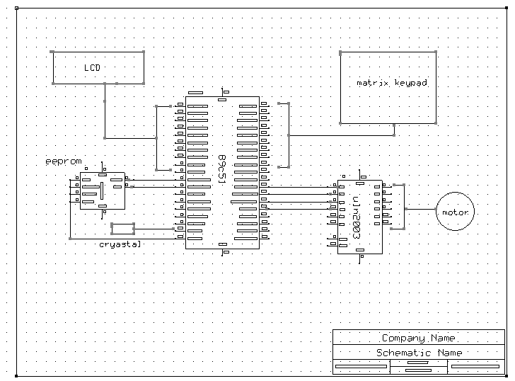

CIRCUIT DESCRIPTION

In this project we have used 8051 microcontroller.20th pin of microcontroller is ground whereas 40th pin is supply.

The system comprises a small electronic unit with a numeric keypad, which is
fixed out side the entry door to control a stepper motor. When an authorized person enters predetermined user ID and password via the keypad, the stepper motor is operated for a limited time so the door can be open. At the end of preset delay, the stepper motor is operated in reverse direction and the door gets locked again.

When the code has been incorrectly entered, the code lock will switch to block mode.
A buzzer is provided for audio acknowledgment of the wrong password.
This project uses regulated 5V, 500mA power supply. 7805 three terminal voltage regulator is used for voltage regulation. Bridge type full wave rectifier is used to rectify the ac out put of secondary of 230/12V step down transformer.

89c51 MICROCONTROLLER ARCHITECTURE

8051 Microcontroller

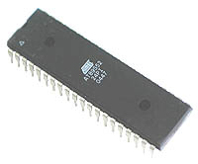

The AT89C51 is a low-power, high-performance CMOS 8-bit microcomputer with 4K
bytes of Flash programmable and erasable read only memory (PEROM). The device
is manufactured using Atmel’s high-density nonvolatile memory technology and is
compatible with the industry-standard MCS-51 instruction set and pin out. The on-chip Flash allows the program memory to be reprogrammed in-system or by a conventional non-volatile memory programmer. By combining a versatile 8-bit CPU with Flash on a monolithic chip, the Atmel AT89C51 is a powerful microcomputer which provides a highly-flexible and cost-effective solution to many embedded control applications.

The AT89C51 provides the following standard features: 4K bytes of Flash, 128 bytes of RAM, 32 I/O lines, two 16-bit timer/counters, a five vector two-level interrupt architecture, a full duplex serial port, on-chip oscillator and clock circuitry. In addition, the AT89C51 is designed with static logic for operation down to zero frequency and supports two software selectable power saving modes. The Idle Mode stops the CPU while allowing the RAM, timer/counters, serial port and interrupt system to continue functioning. The Power-down Mode saves the RAM contents but freezes the oscillator disabling all other chip functions until the next hardware reset.

Pin Configuration:

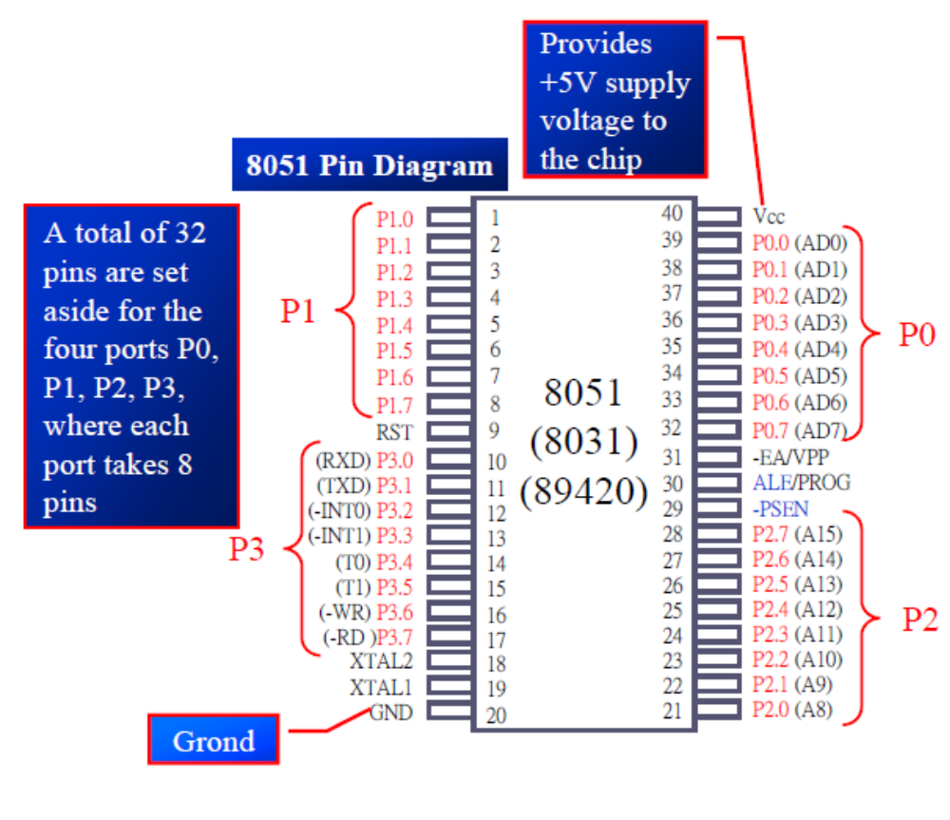

Pin Description:

VCC:
Supply voltage.

GND:
Ground.

Port 0:
Port 0 is an 8-bit open-drain bi-directional I/O port. As an output port, each pin can sink eight TTL inputs. When 1s are written to port 0 pins, the pins can be used as high impedance inputs. Port 0 may also be configured to be the multiplexed low order
Address /data bus during accesses to external program and data memory. In this mode P0 has internal pull ups. Port 0 also receives the code bytes during Flash programming,
and outputs the code bytes during program verification. External pull ups are required during program verification.

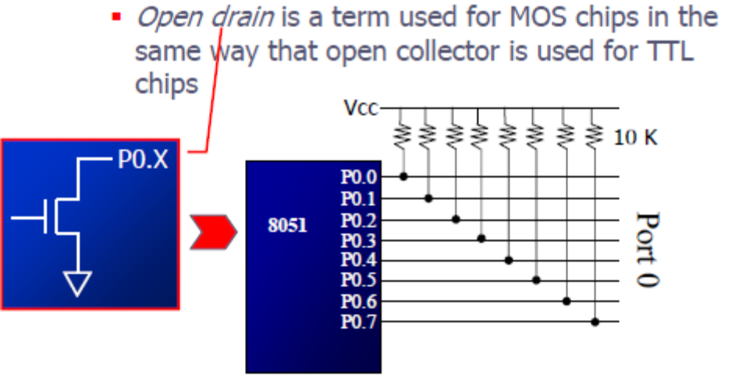

Port 1:
Port 1 is an 8-bit bi-directional I/O port with internal pull-ups. The Port 1 output buffers can sink/source four TTL inputs. When 1s are written to Port 1 pins they are pulled high by the internal pull-ups and can be used as inputs. As inputs, Port 1 pins that are externally being pulled low will source current (IIL) because of the internal pull-ups. Port 1 also receives the low-order address bytes during Flash programming and verification.

Port 2:
Port 2 is an 8-bit bi-directional I/O port with internal pull-ups. The Port 2 output buffers can sink/source four TTL inputs. When 1s are written to Port 2 pins they are pulled high by the internal pull-ups and can be used as inputs. As inputs, Port 2 pins that are externally being pulled low will source current (IIL) because of the internal pull-ups.
Port 2 emits the high-order address byte during fetches from external program memory and during accesses to external data memory that use 16-bit addresses (MOVX @ DPTR). In this application, it uses strong internal pull-ups when emitting 1s. During accesses to external data memory that use 8-bit addresses (MOVX @ RI), Port 2 emits the contents of the P2 Special Function Register. Port 2 also receives the high-order address bits and some control signals during Flash programming and verification.

Port 3:
Port 3 is an 8-bit bi-directional I/O port with internal pull-ups. The Port 3 output buffers can sink/source four TTL inputs. When 1s are written to Port 3 pins they are pulled high by the internal pull-ups and can be used as inputs. As inputs, Port 3 pins that are externally being pulled low will source current (IIL) because of the pull-ups. Port 3 also serves the functions of various special features of the AT89C51 as listed below: Port 3 also receives some control signals for Flash programming and verification.

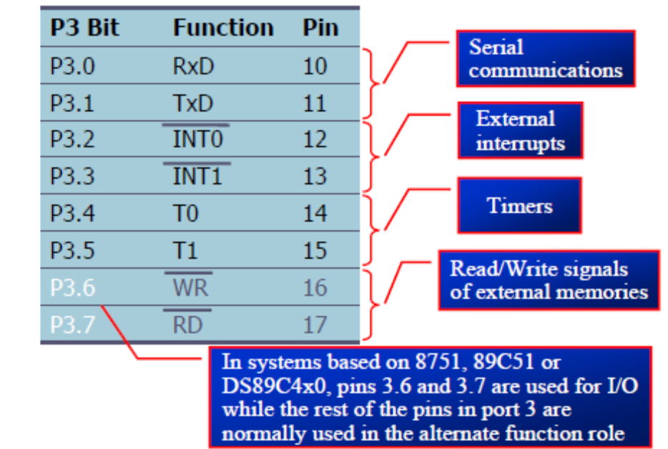

ALE/PROG:
Address Latch Enable output pulse for latching the low byte of the address during accesses to external memory. This pin is also the program pulse input (PROG) during Flash programming. In normal operation ALE is emitted at a constant rate of 1/6 the oscillator frequency, and may be used for external timing or clocking purposes. Note, however, that one ALE
Pulse is skipped during each access to external Data Memory. If desired, ALE operation can be disabled by setting bit 0 of SFR location 8EH. With the bit set, ALE is active only during a MOVX or MOVC instruction. Otherwise, the pin is weakly pulled high. Setting the ALE-disable bit has no effect if the microcontroller is in external execution mode.

RESET:
Reset input. A high on this pin for two machine cycles while the oscillator is running resets the device.

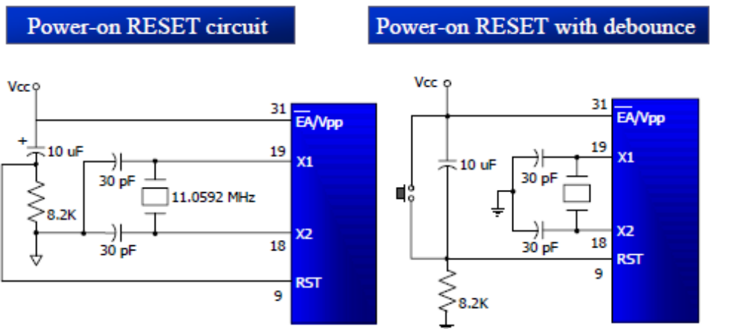

PSEN:
Program Store Enable is the read strobe to external program memory. When the AT89C51 is executing code from external program memory, PSEN is activated twice each machine cycle, except that two PSEN activations are skipped during each access to external data memory.

EA/VPP:
External Access Enable. EA must be strapped to GND in order to enable the device to fetch code from external program memory locations starting at 0000H up to FFFFH. Note, however, that if lock bit 1 is programmed, EA will be internally latched on reset. EA should be strapped to VCC for internal program executions. This pin also receives the 12-volt programming enable voltage (VPP) during Flash programming, for parts that require 12-volt VPP.

XTAL1:
Input to the inverting oscillator amplifier and input to the internal clock operating circuit.

XTAL2:
Output from the inverting oscillator amplifier.

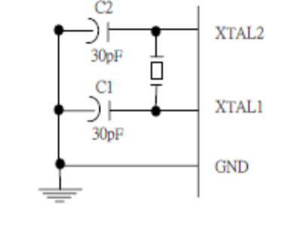

Oscillator Characters:
XTAL1 and XTAL2 are the input and output, respectively, of an inverting amplifier which can be configured for use as an on-chip oscillator, as shown in Figure 1. Either a quartz crystal or ceramic resonator may be used. To drive the device from an external clock source, XTAL2 should be left unconnected while XTAL1 is driven as shown in Figure 2. There are no requirements on the duty cycle of the external clock signal, since the input to the internal clocking circuitry is through a divide-by-two flip-flop, but minimum and maximum voltage high and low time specifications must be observed.

Idle Mode:
In idle mode, the CPU puts itself to sleep while all the on chip peripherals remain active. The mode is invoked by software. The content of the on-chip RAM and all the special functions registers remain unchanged during this mode. The idle mode can be terminated by any enabled interrupt or by a hardware reset. It should be noted that when idle is terminated by a hard ware reset, the device normally resumes program execution, from where it left off, up to two machine cycles before the internal reset algorithm takes control. On-chip hardware inhibits access to internal RAM in this event, but access to the port pins is not inhibited. To eliminate the possibility of an unexpected write to a port pin when Idle is terminated by reset, the instruction following the one that invokes Idle should not be one that writes to a port pin or to external memory.

Programming the Flash:
The AT89C51 is normally shipped with the on-chip Flash memory array in the erased state (that is, contents = FFH) and ready to be programmed. The programming interface accepts either a high-voltage (12-volt) or a low-voltage (VCC) program enable signal. The low-voltage programming mode provides a convenient way to program the AT89C51 inside the user’s system, while the high-voltage programming mode is compatible with conventional third party Flash or EPROM programmers. The AT89C51 is shipped with either the high-voltage or low-voltage programming mode enabled.
The AT89C51 code memory array is programmed byte by byte in either programming mode. To program any nonblank byte in the on-chip Flash Memory, the entire memory must be erased using the Chip Erase Mode.

Programming Algorithm:
Before programming the AT89C51, the address, data and control signals should be set up according to the Flash programming mode table. To program the AT89C51, take the following steps.
1. Input the desired memory location on the address lines.
2. Input the appropriate data byte on the data lines.
3. Activate the correct combination of control signals.
4. Raise EA/VPP to 12V for the high-voltage programming mode.
5. Pulse ALE/PROG once to program a byte in the Flash array or the lock bits. The byte-write cycle is self-timed and typically takes no more than 1.5 ms.

Repeat steps 1 through 5, changing the address and data for the entire array or until the end of the object file is reached.

Data Polling: The AT89C51 features Data Polling to indicate the end of a write cycle. During a write cycle, an attempted read of the last byte written will result in the complement of the written datum on PO.7. Once the write cycle has been completed, true data are valid on all outputs, and the next cycle may begin. Data Polling may begin any time after a write cycle has been initiated.

Ready/Busy: The progress of byte programming can also be monitored by the RDY/BSY output signal. P3.4 is pulled low after ALE goes high during programming to indicate BUSY. P3.4 is pulled high again when programming is done to indicate READY.

Program Verify: If lock bits LB1 and LB2 have not been programmed, the programmed code data can be read back via the address and data lines for verification. The lock bits cannot be verified directly. Verification of the lock bits is achieved by observing that their features are enabled.

Chip Erase: The entire Flash array is erased electrically by using the proper combination of control signals and by holding ALE/PROG low for 10 ms. The code array is written with all “1”s. The chip erase operation must be executed before the code memory can be re-programmed.

Reading the Signature Bytes: The signature bytes are read by the same procedure as a normal verification of locations 030H, 031H, and 032H, except that P3.6 and P3.7 must be pulled to a logic low. The values returned are as follows.
(030H) = 1EH indicates manufactured by Atmel
(031H) = 51H indicates 89C51
(032H) = FFH indicates 12V programming
(032H) = 05H indicates 5V programming

Special Function Registers:

A map of the on-chip memory area called the Special Function Register (SFR) space. Note that not all of the addresses are occupied, and unoccupied addresses may not be implemented on the chip. Read accesses to these addresses will in general return random data, and write accesses will have an indeterminate effect. User software should not write 1s to these unlisted locations, since they may be used in future products to invoke.

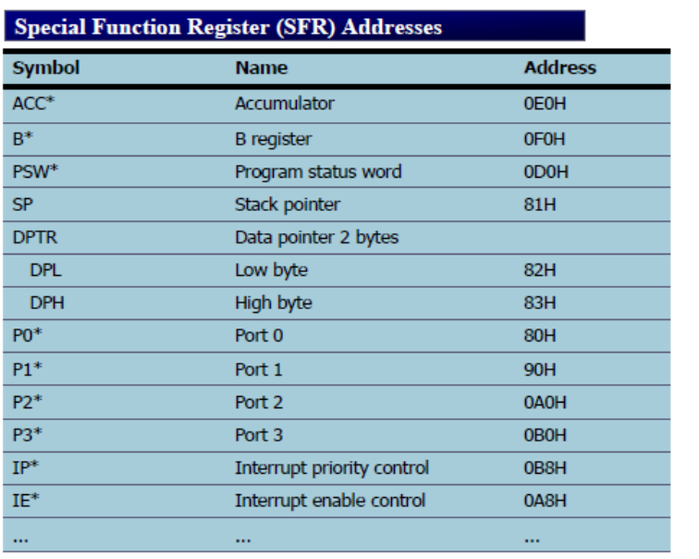

Data Memory:
The AT89C52 implements 256 bytes of on-chip RAM. The upper 128 bytes occupy a parallel address space to the Special Function Registers. That means the upper 128 bytes have the same addresses as the SFR space but are physically separate from SFR space. When an instruction accesses an internal location above address 7FH, the address mode used in the instruction specifies whether the CPU accesses the upper 128 bytes of RAM or the SFR space. Instructions that use direct addressing access SFR space. new features. In that case, the reset or inactive values of the new bits will always be 0.

Interrupt Registers:
The individual interrupt enable bits are in the IE register. Two priorities can be set for each of the six interrupt sources in the IP register. specifies whether the CPU accesses the upper 128 bytes of RAM or the SFR space. Instructions that use direct addressing access SFR space. For example, the following direct addressing instruction accesses the SFR at location 0A0H (which is P2).
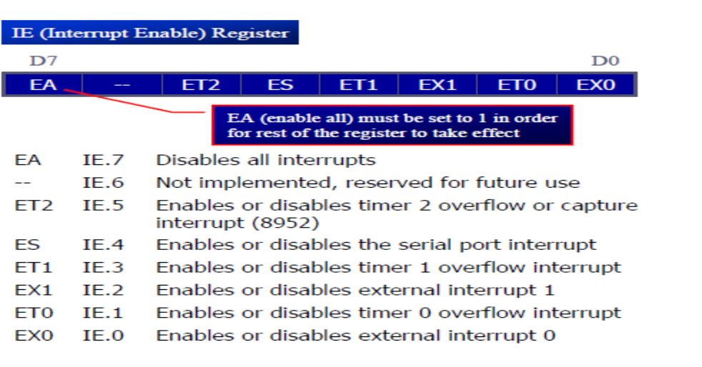
Instructions that use indirect addressing access the upper 128 bytes of RAM. For example, the following indirect addressing instruction, where R0 contains 0A0H, accesses the data byte at address 0A0H, rather than P2 (whose address is 0A0H).

Timer 0 and 1:
Timer 0 and Timer 1 in the AT89C52 operate the same way as Timer 0 and Timer 1 in the AT89C51.

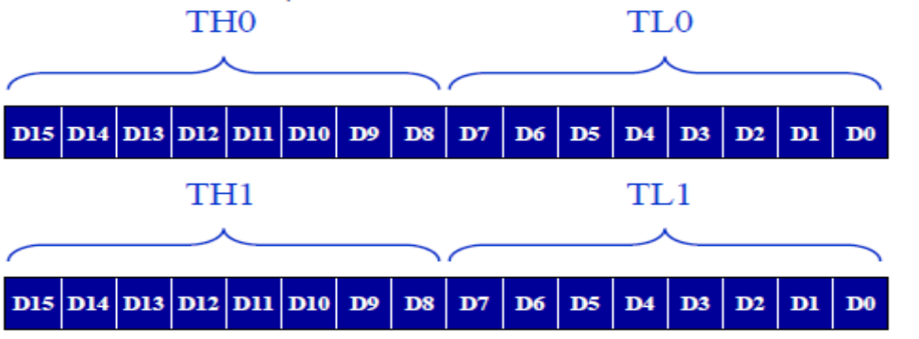

Timer 2:
Timer 2 is a 16-bit Timer/Counter that can operate as either a timer or an event counter. The type of operation is selected by bit C/T2 in the SFR T2CON. Timer 2 has three operating modes: capture, auto-reload (up or down counting), and baud rate generator. The modes are selected by bits in T2CON. Timer 2 consists of two 8-bit registers, TH2 and TL2. In the Timer function, the TL2 register is incremented every machine cycle. Since a machine cycle consists of 12 oscillator periods, the count rate is 1/12 of the oscillator frequency. In the Counter function, the register is incremented in response to a 1-to-0 transition at its corresponding external input pin, T2. In this function, the external input is sampled during S5P2 of every machine cycle. When the samples show a high in one cycle and a low in the next cycle, the count is incremented. The new count value appears in the register during S3P1 of the cycle following the one in which the transition was detected. Since two machine cycles (24 oscillator periods) are required to recognize a 1-to-0 transition, the maximum count rate is 1/24 of the oscillator frequency. To ensure that a given level is sampled at least once before it changes, the level should be held for at least one full machine cycle.

Capture Mode:
In the capture mode, two options are selected by bit EXEN2 in T2CON. If EXEN2 = 0, Timer 2 is a 16-bit timer or counter which upon overflow sets bit TF2 in T2CON. This bit can then be used to generate an interrupt. If EXEN2 = 1, Timer 2 performs the same operation, but a 1- to-0 transition at external input T2EX also causes the current value in TH2 and TL2 to be captured into CAP2H and RCAP2L, respectively. In addition, the transition at T2EX causes bit EXF2 in T2CON to be set. The EXF2 bit, like TF2, can generate an interrupt.

Auto-reload (Up or Down Counter):
Timer 2 can be programmed to count up or down when configured in its 16-bit auto-reload mode. This feature is invoked by the DCEN (Down Counter Enable) bit located in the SFR T2MOD. Upon reset, the DCEN bit is set to 0 so that timer 2 will default to count up. When DCEN is set, Timer 2 can count up or down, depending on the value of the T2EX pin.

Interrupts:
The AT89C52 has a total of six interrupt vectors: two external interrupts (INT0 and INT1), three timer interrupts (Timers 0, 1, and 2), and the serial port interrupt. Each of these interrupt sources can be individually enabled or disabled by setting or clearing a bit in Special Function Register IE. IE also contains a global disable bit, EA, which disables all interrupts at once. Note that bit position IE.6 is unimplemented. In the AT89C51, bit position IE.5 is also unimplemented. User software should not write 1s to these bit positions, since they may be used in future AT89 products. Timer 2 interrupt is generated by the logical OR of bits TF2 and EXF2 in register T2CON. Neither of these flags cleared by hardware when the service routine is vectored . In fact, the service routine may have to determine whether it was TF2 or EXF2 that generated the interrupt, and that bit will have to be cleared in software. . The Timer 0 and Timer 1 flags, TF0 and TF1, are set at S5P2 of the cycle in which the timers overflow.

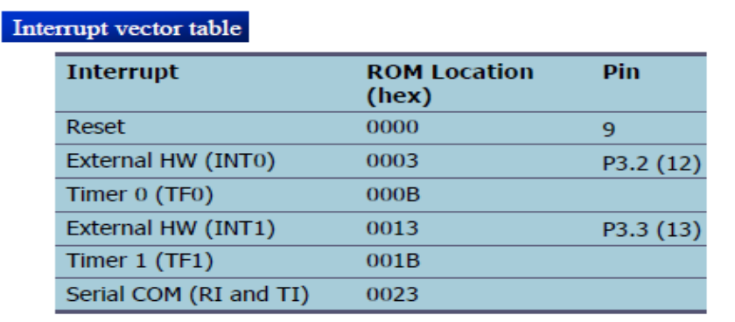

The values are then polled by the circuitry in the next cycle.However, the Timer 2 flag, TF2, is set at S2P2 and is polled in the same cycle in which the timer overflows.

SERIAL COMMUNICATION:

Computers transfer data in two ways:
Parallel: Often 8 or more lines (wire conductors) are used to transfer data to a device that is only a few feet away.

Serial: To transfer to a device located many meters away, the serial method is used. The data is sent one bit at a time.

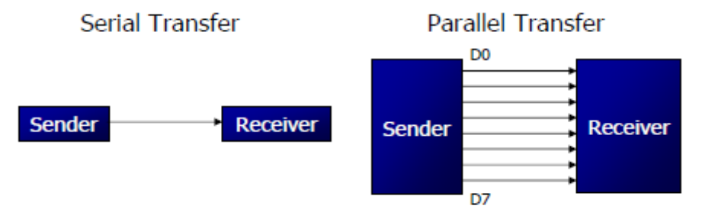

At the transmitting end, the byte of data must be converted to serial bits using parallel-in-serial-out shift register. At the receiving end, there is a serial in-parallel-out shift register to receive the serial data and pack them into byte. When the distance is short, the digital signal can be transferred as it is on a simple wire and requires no modulation. If data is to be transferred on the telephone line, it must be converted from 0s and 1s to audio tones.
This conversion is performed by a device called a modem, “Modulator/demodulator”.
Serial data communication uses two methods; Synchronous method transfers a block of data at a time Asynchronous method transfers a single byte at a time It is possible to write software to use either of these methods, but the programs can be tedious and long. There are special IC chips made by many manufacturers for serial communications UART (universal asynchronous Receiver transmitter) USART (universal synchronous asynchronous Receiver-transmitter). If data can be transmitted and received, it is a duplex transmission. If data transmitted one way a time, it is referred to as half duplex. If data can go both ways at a time, it is full duplex.

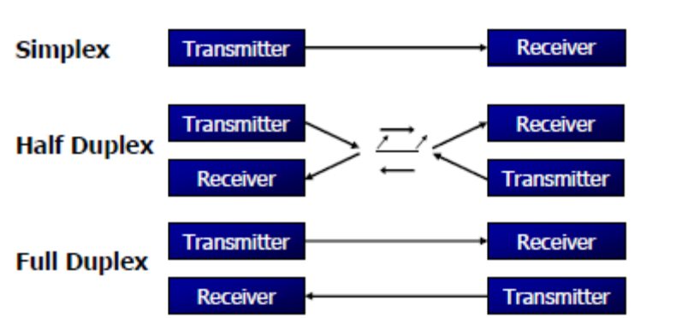

A protocol is a set of rules agreed by both the sender and receiver on.
When the data begins and ends. Asynchronous serial data communication is widely used for character-oriented transmissions;
Each character is placed in between start and stop bits, this is called framing.
Block-oriented data transfers use the synchronous method.
The start bit is always one bit, but the stop bit can be one or two bits The start bit is always a 0 (low) and the stop bit(s) is 1 (high)

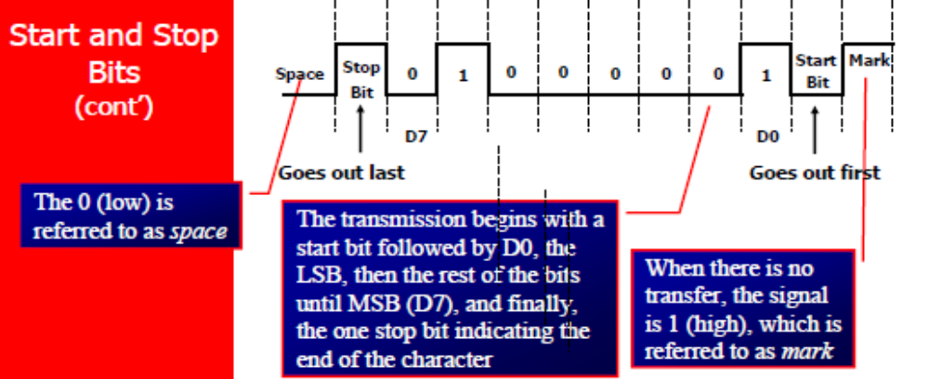

SBUF is an 8-bit register used solely for serial communication. For a byte data to be transferred via the TxD line, it must be placed in the SBUF Register. The moment a byte is written into SBUF, it is framed with the start and stop bits and transferred serially via the TxD line SBUF holds the byte of data when it is received by 8051 RxD line. When the bits are received serially via RxD, the 8051 de-frames it by eliminating the stop and start bits, making a byte out of the data received, and then placing it in SBUF
MOV SBUF,#’D’ ;load SBUF=44h, ASCII for ‘D’
MOV SBUF,A ;copy accumulator into SBUF
MOV A,SBUF ;copy SBUF into accumulator

SCON is an 8-bit register used to program the start bit, stop bit, and data bits of data framing, among other things.

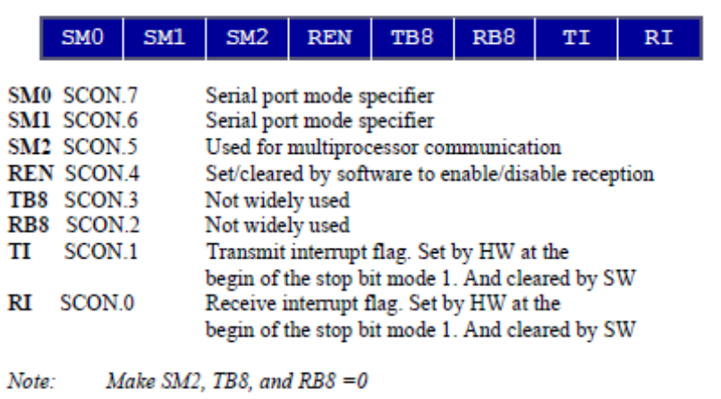

SM0, SM1: They determine the framing of data by specifying the number of bits per character, and the start and stop bits.

SM2: This enables the multiprocessing capability of the 8051.

REN (receive enable): It is a bit-addressable register. When it is high, it allows 8051 to receive data.

RxD pin: If low, the receiver is disable.

TI (transmit interrupt): When 8051 finishes the transfer of 8-bit character. It raises TI flag to indicate that it is ready to transfer another byte.TI bit is raised at the beginning of the stop bit

RI (receive interrupt): When 8051 receives data serially via RxD, it gets rid of the start and stop bits and places the byte in SBUF register. It raises the RI flag bit to indicate that a byte has been received and should be picked up before it is lost. RI is raised halfway through the stop bit.

EEPROM(24C02)

DESCRIPTION

This specification covers a range of 2K bits I2C bus EEPROM products, the ST24/25C02, the ST24C02R and ST24/25W02. In the text, products are referred to as ST24/25x02, where "x" is: "C" for Standard version. The ST24/25x02 are 2K bit electrically erasable programmable memories (EEPROM), organized as 256 x 8 bits. They are manufactured in SGSTHOMSON’s Hi-Endurance Advanced CMOS technology which guarantees an endurance of one million erase/write cycles with a data retention of 40 years.

The memories operate with a power supply value as low as 1.8V for the ST24C02R only. Both Plastic Dual-in-Line and Plastic Small Outline packages are available.The memories are compatible with the I2C standard,two wire serial interface which uses a bi-directional data bus and serial clock. The memories carry a built-in 4 bit, unique device identification code (1010) corresponding to the I2C bus definition. This is used together with 3 chip enable inputs (E2, E1, E0) so that up to 8 x 2K devices may be attached to the I2C bus and selected individually.

The memories behave as a slave device in the I2C protocol with all memory operations synchronized by the serial clock. Read and write operations are initiated by a START condition generated by thebus master. The START condition is followed by a stream of 7 bits (identification code 1010), plus oneread/write bit and terminated by an acknowledge bit.

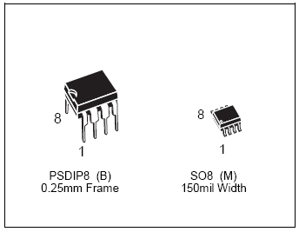

Features

- 1 MILLION ERASE/WRITE CYCLES with
- 40 YEARS DATA RETENTION
- SINGLE SUPPLY VOLTAGE:
– 3V to 5.5V for ST24x02 versions
– 2.5V to 5.5V for ST25x02 versions
– 1.8V to 5.5V for ST24C02R version only
- HARDWARE WRITE CONTROL VERSIONS:
- ST24W02 and ST25W02
- TWO WIRE SERIAL INTERFACE, FULLY I2C
- BUS COMPATIBLE
- BYTE and MULTIBYTE WRITE (up to 4BYTES)
- PAGE WRITE (up to 8 BYTES)
- BYTE, RANDOM and SEQUENTIAL READ MODES
- SELF TIMED PROGRAMMING CYCLE
- AUTOMATIC ADDRESS INCREMENTING
- ENHANCED ESD/LATCH-UP PERFORMANCES

PIN DESCRIPTION

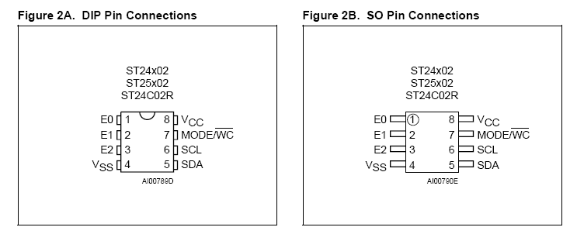

When writing data to the memory it responds to the 8 bits received by asserting an acknowledge bit during the 9th bit time. When data is read by the bus master, it acknowledges the receipt of the data bytes in the same way. Data transfers are terminated with a STOP condition.

Power On Reset: VCC lock out write protect. In order to prevent data corruption and inadvertent
write operations during power up, a Power On Reset (POR) circuit is implemented.

Until the VCC voltage has reached the POR threshold value, the internal reset is active, all operations are disabled and the device will not respond to any command. In the same way, when VCC drops down from the operating voltage to below the POR threshold value, all operations are disabled and the device will not respond to any command. A stable VCC must be applied before applying any logic signal.

SIGNAL DESCRIPTIONS

Serial Clock (SCL). The SCL input pin is used to synchronize all data in and out of the memory. A resistor can be connected from the SCL line to VCC to act as a pull up .

Serial Data (SDA). The SDA pin is bi-directional and is used to transfer data in or out of the memory. It is an open drain output that may be wire-OR’ed with other open drain or open collector signals on the bus. A resistor must be connected from the SDA bus line to VCC to act as pull up.

Chip Enable (E2 - E0). These chip enable inputs are used to set the 3 least significant bits (b3, b2, b1) of the 7 bit device select code. These inputs may be driven dynamically or tied to VCC or VSS to establish the device select code.

Mode (MODE). The MODE input is available on pin 7 (see also WC feature) and may be driven dynamically. It must be at VIL or VIH for the Byte Write mode, VIH for Multibyte Write mode or VIL for Page Write mode. When unconnected, the MODE input is internally read as a VIH (Multibyte Write mode).

Write Control (WC). An hardware Write Control feature (WC) is offered only for ST24W02 and
ST25W02 versions on pin 7. This feature is usefull to protect the contents of the memory from any erroneous erase/write cycle. The Write Control signal is used to enable (WC = VIH) or disable (WC = VIL) the internal write protection. When unconnected, the WC input is internally read as VIL and the memory area is not write protected.

DEVICE OPERATION

I2C Bus Background The ST24/25x02 support the I2C protocol. This protocol defines any device that sends data onto the bus as a transmitter and any device that reads the data as a receiver. The device that controls the data transfer is known as the master and the other as the slave. The master will always initiate a data transfer and will provide the serial clock for synchronisation.
The ST24/25x02 are always slave devices in all communications.

Start Condition. START is identified by a high to low transition of the SDA line while the clock SCL is stable in the high state. A START condition must precede any command for data transfer. Except during a programming cycle, the ST24/25x02 continuously monitor the SDA and SCL signals for a START condition and will not respond unless one is given.

Stop Condition. STOP is identified by a low to high transition of the SDA line while the clock SCL is stable in the high state. A STOP condition terminates communication between the ST24/25x02 and the bus master. A STOP condition at the end of a Read command, after and only after a No Acknowledge, forces the standby state. A STOP condition at the end of a Write command triggers the internal EEPROM write cycle.

Acknowledge Bit (ACK). An acknowledge signal is used to indicate a successfull data transfer. The bus transmitter, either master or slave, will release the SDA bus after sending 8 bits of data. During the 9th clock pulse period the receiver pulls the SDA bus low to acknowledge the receipt of the 8 bits of data.

Data Input. During data input the ST24/25x02 sample the SDA bus signal on the rising edge of
the clock SCL. Note that for correct device operation the SDA signal must be stable during the clock low to high transition and the data must change ONLY when the SCL line is low.

Memory Addressing. To start communication between the bus master and the slave ST24/25x02, the master must initiate a START condition. Following this, the master sends onto the SDA bus line 8 bits (MSB first) corresponding to the device select code (7 bits) and a READ or WRITE bit.

LCD
(LIQUID CRYSTAL DISPLAY)

Liquid Crystal Displays (LCDs) are categorized as none missive display devices,in that respect, they do not produce any form of light like a Cathode Ray Tube (CRT). LCDs either pass or block light that is reflected from an external light source or provided by a back/side lighting system.

There are two modes of operation for LCDs:

Normal White mode: the display is white or clear and allows light to pass through.

Normal Black Mode: the display is dark and all light is diffused. Virtually all displays in production for PC/Workstation use are normal white mode to optimize contrast and speed.

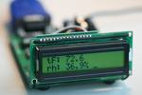

Polarizers are an integral part of a LCD display, possessing the unique property of only passing light if it is oriented in a specific (oriented) direction. To utilize this phenomenon in TN LC displays, the bottom polarizer orients incoming light in one direction. The oriented light passes through the LC material and is either unaltered or "bent" 90 degrees. Depending on the orientation of the top polarizer, this light will either pass through or be diffused. If the light is diffused, it will appear as a dark area.

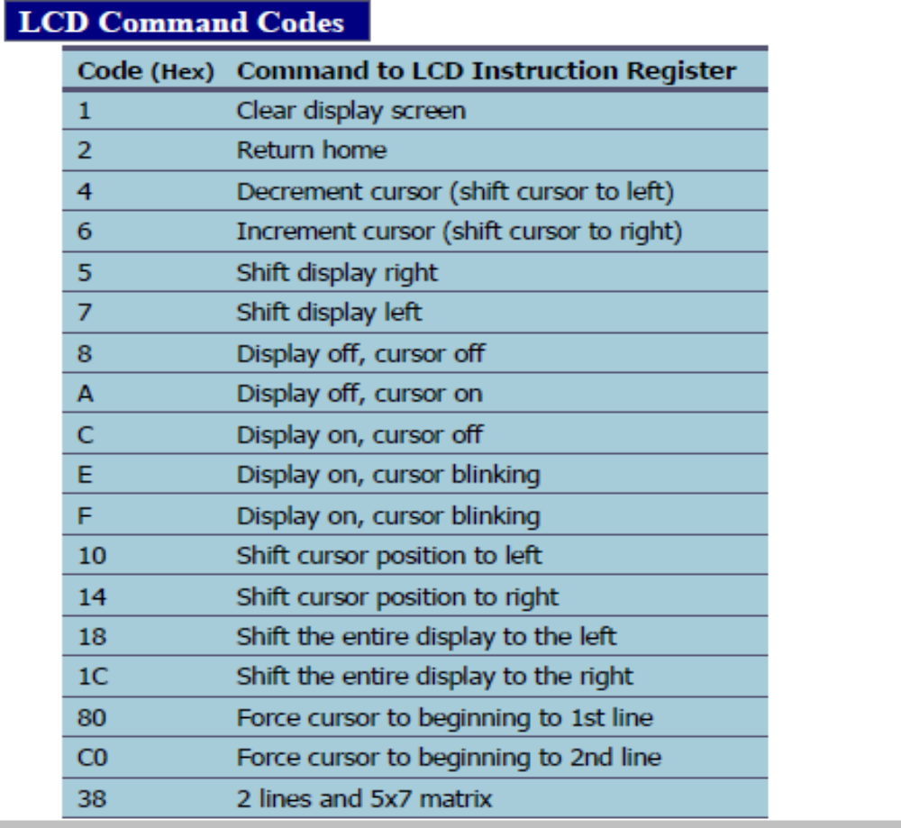

STEPPER MOTOR

A stepper motor (or step motor) is a brushless, synchronous electric motor that can divide a full rotation into a large number of steps. The motor's position can be controlled precisely without any feedback mechanism (see Open-loop controller), as long as the motor is carefully sized to the application. Stepper motors are similar to switched reluctance motors (which are very large stepping motors with a reduced pole count, and generally are closed-loop commutated.)

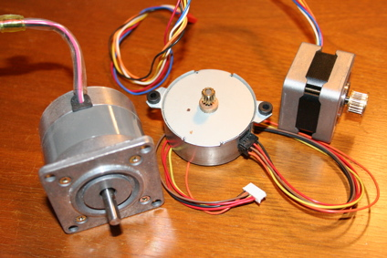

Fundamentals of Operation
Stepper motors operate differently from DC brush motors, which rotate when voltage is applied to their terminals. Stepper motors, on the other hand, effectively have multiple "toothed" electromagnets arranged around a central gear-shaped piece of iron. The electromagnets are energized by an external control circuit, such as a microcontroller. To make the motor shaft turn, first one electromagnet is given power, which makes the gear's teeth magnetically attracted to the electromagnet's teeth. When the gear's teeth are thus aligned to the first electromagnet, they are slightly offset from the next electromagnet. So when the next electromagnet is turned on and the first is turned off, the gear rotates slightly to align with the next one, and from there the process is repeated. Each of those slight rotations is called a "step," with an integer number of steps making a full rotation. In that way, the motor can be turned by a precise angle.
Stepper motor characteristics
- Stepper motors are constant power devices.
- As motor speed increases, torque decreases.
- The torque curve may be extended by using current limiting drivers and increasing the driving voltage.
- Steppers exhibit more vibration than other motor types, as the discrete step tends to snap the rotor from one position to another.
- This vibration can become very bad at some speeds and can cause the motor to lose torque.
- The effect can be mitigated by accelerating quickly through the problem speeds range, physically damping the system, or using a micro-stepping driver.
- Motors with a greater number of phases also exhibit smoother operation than those with fewer phases.

How Stepper Motors Work
Stepper motors consist of a permanent magnet rotating shaft, called the rotor, and electromagnets on the stationary portion that surrounds the motor, called the stator. Figure 1 illustrates one complete rotation of a stepper motor. At position 1, we can see that the rotor is beginning at the upper electromagnet, which is currently active (has voltage applied to it). To move the rotor clockwise (CW), the upper electromagnet is deactivated and the right electromagnet is activated, causing the rotor to move 90 degrees CW, aligning itself with the active magnet. This process is repeated in the same manner at the south and west electromagnets until we once again reach the starting position.

In the above example, we used a motor with a resolution of 90 degrees or demonstration purposes. In reality, this would not be a very practical motor for most applications. The average stepper motor's resolution -- the amount of degrees rotated per pulse -- is much higher than this. For example, a motor with a resolution of 5 degrees would move its rotor 5 degrees per step, thereby requiring 72 pulses (steps) to complete a full 360 degree rotation.

You may double the resolution of some motors by a process known as "half-stepping". Instead of switching the next electromagnet in the rotation on one at a time, with half stepping you turn on both electromagnets, causing an equal attraction between, thereby doubling the resolution.

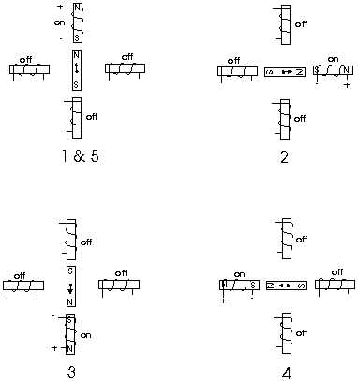

Figure 1
As you can see in Figure 2, in the first position only the upper electromagnet is active, and the rotor is drawn completely to it. In position 2, both the top and right electromagnets are active, causing the rotor to position itself between the two active poles. Finally, in position 3, the top magnet is deactivated and the rotor is drawn all the way right. This process can then be repeated for the entire rotation.
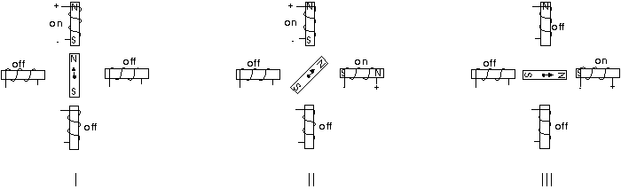

Figure 2

There are several types of stepper motors. 4-wire stepper motors contain only two electromagnets, however the operation is more complicated than those with three or four magnets, because the driving circuit must be able to reverse the current after each step. For our purposes, we will be using a 6-wire motor.
Unlike our example motors which rotated 90 degrees per step, real-world motors employ a series of mini-poles on the stator and rotor to increase resolution. Although this may seem to add more complexity to the process of driving the motors, the operation is identical to the simple 90 degree motor we used in our example.
An example of a multipole motor can be seen in Figure 3. In position 1, the north pole of the rotor's perminant magnet is aligned with the south pole of the stator's electromagnet. Note that multiple positions are alligned at once. In position 2, the upper electromagnet is deactivated and the next one to its immediate left is activated, causing the rotor to rotate a precise amount of degrees. In this example, after eight steps the sequence repeats.

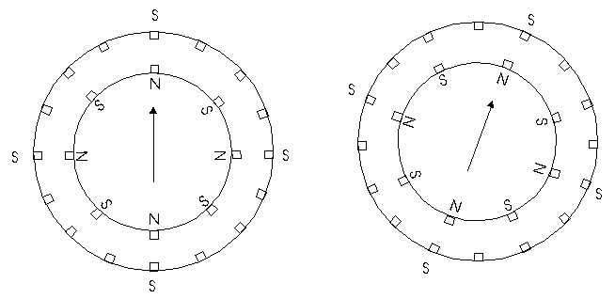

Figure 3

Stepper Motor Driver IC ULN2003
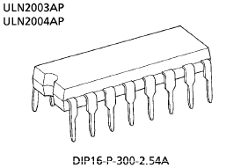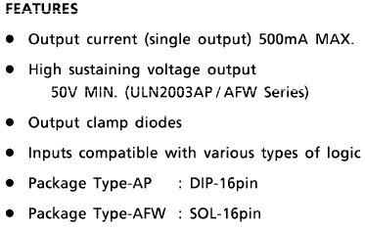

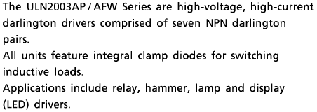

Pin Connection:
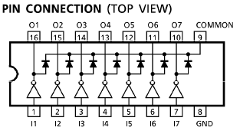

DIODE

A diode is a two-terminal electronic component that conducts electric current in only one direction. The term usually refers to a semiconductor diode, the most common type today, which is a crystal of semiconductor connected to two electrical terminals, a P-N junction.
The most common function of a diode is to allow an electric current in one direction (called the diode's forward direction) while blocking current in the opposite direction (the reverse direction). Thus, the diode can be thought of as an electronic version of a check valve. This unidirectional behavior is called rectification, and is used to convert alternating current to direct current, and remove modulation from radio signals in radio receivers.

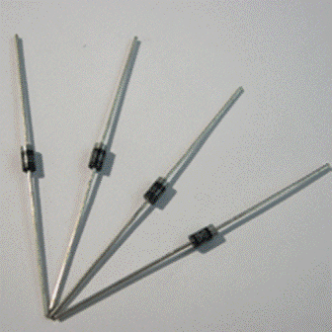

RESISTANCE

The electrical resistance of an object is a measure of its opposition to the passage of a steady electric current. An object of uniform cross section will have a resistance proportional to its length and inversely proportional to its cross-sectional area, and proportional to the resistivity of the material.

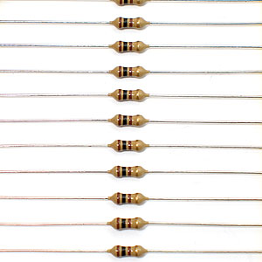

The resistance of a resistive object determines the amount of current through the object for a given potential difference across the object, in accordance with Ohm's law: I =V/R
R is the resistance of the object, measured in ohms, equivalent to J·s/C² V is the potential difference across the object, measured in volts I is the current through the object, measured in amperes
For a wide variety of materials and conditions, the electrical resistance does not depend on the amount of current through or the amount of voltage across the object, meaning that the resistance R is constant for the given temperature and material. Therefore, the resistance of an object can be defined as the ratio of voltage to current.In the case of nonlinear objects (not purely resistive, or not obeying Ohm's law), this ratio can change as current or voltage changes; the ratio taken at any particular point, the inverse slope of a chord to an I–V curve, is sometimes referred to as a "chordal resistance" or "static resistance".[

CRYSTAL OSCILLATOR

A crystal oscillator is an electronic circuit that uses the mechanical resonance of a vibrating crystal of piezoelectric material to create an electrical signal with a very precise frequency. This frequency is commonly used to keep track of time (as in quartz wristwatches), to provide a stable clock signal for digital integrated circuits, and to stabilize frequencies for radio transmitters and receivers. The most common type of piezoelectric resonator used is the quartz crystal, so oscillator circuits designed around them were called "crystal oscillators".
Quartz crystals are manufactured for frequencies from a few tens of kilohertz to tens of megahertz.

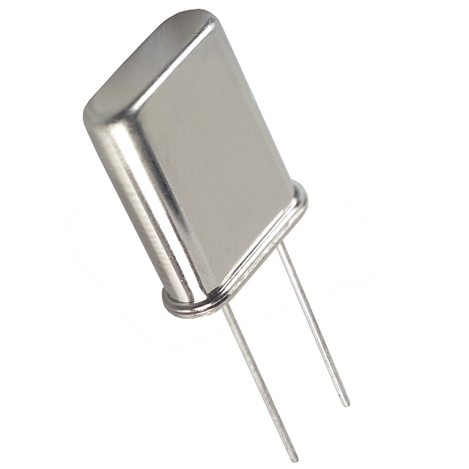

A quartz crystal can be modelled as an electrical network with a low impedance (series) and a high impedance (parallel) resonance point spaced closely together.

VOLTAGE REGULATOR

A voltage regulator is an electrical regulator designed to automatically maintain a constant voltage level.It may use an electromechanical mechanism, or passive or active electronic components. Depending on the design, it may be used to regulate one or more AC or DC voltages.
Voltage regulators operate by comparing the actual output voltage to some internal fixed reference voltage. Any difference is amplified and used to control the regulation element in such a way as to reduce the voltage error. This forms a negative feedback control loop; increasing the open-loop gain tends to increase regulation accuracy but reduce stability (avoidance of oscillation, or ringing during step changes). There will also be a trade-off between stability and the speed of the response to changes.
If the output voltage is too low the regulation element is commanded to produce a higher output voltage - by dropping less of the input voltage or to draw input current for longer periods
if the output voltage is too high the regulation element will normally be commanded to produce a lower voltage. However, many regulators have over-current protection, so that they will entirely stop sourcing current (or limit the current in some way) if the output current is too high, and some regulators may also shut down if the input voltage is outside a given range
.
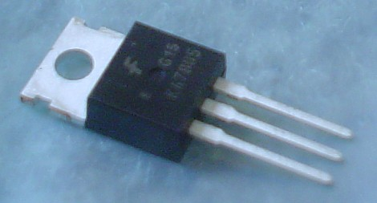
CAPACITOR

A capacitor or condenser is a passive electronic component consisting of a pair of conductors separated by a dielectric (insulator). When a potential difference (voltage) exists across the conductors, an electric field is present in the dielectric. This field stores energy and produces a mechanical force between the conductors. The effect is greatest when there is a narrow separation between large areas of conductor, hence capacitor conductors are often called plates.
Capacitors are widely used in electronic circuits to block the flow of direct current while allowing alternating current to pass, to filter out interference, to smooth the output of power supplies, and for many other purposes. They are used in resonant circuits in radio frequency equipment to select particular frequencies from a signal with many frequencies.

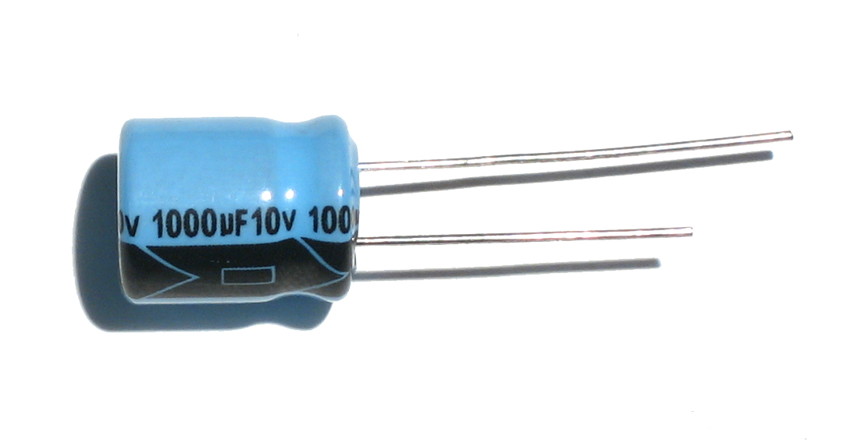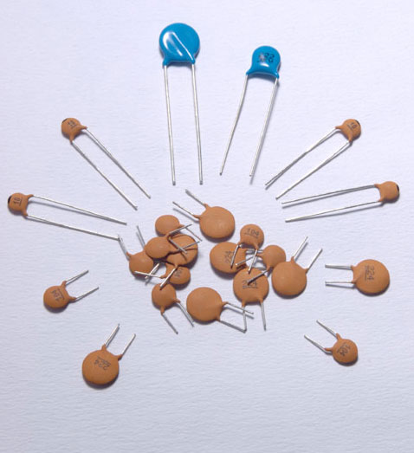

TYPES OF CAPACITOR:

Aluminum Electrolytic Capacitors
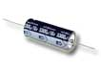 | 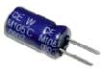 | 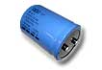 | 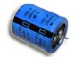 | 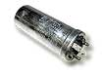 | 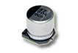
Axial Leads | Radial Leads | Computer Grade | Snap Mount | Twist Lok | Surface Mount

Tantalum Capacitors
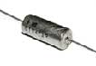 | 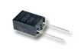 | 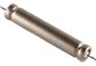 | 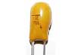 | 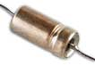 | 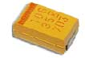
Solid Tantalum  ( Axial Leads ) | Solid Tantalum  ( Radial Leads ) | Foil Tantalum  ( Axial Leads ) | Dipped Tantalum | Wet Tantalum | Surface Mount

Ceramic Capacitors
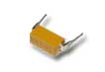 | 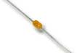 | 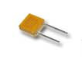 | 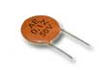 | 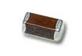
Dip Guard | Monolithic  ( Axial Leads ) | Monolithic  ( Radial Leads ) | Disc | Surface Mount

Film Capacitors
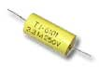 | 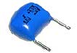 | 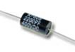 | 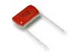 | 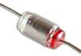
Polyester  ( Axial Leads ) | Polyester  ( Radial Leads ) | Polypropylene  ( Axial Leads ) | Polypropylene  ( Radial Leads ) | Polystyrene  ( Axial Leads )

Mica Capacitors
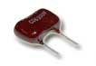 | 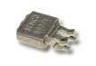 | 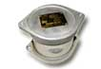
Dipped Mica | Metal Clad | Transmitting

Oil Capacitors
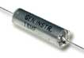 | 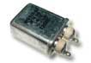
Hermetically Sealed  ( Axial Leads ) | Hermetically Sealed  ( Radial Leads )

Other Capacitor Types
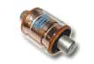 | 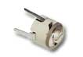 | 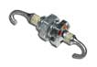
Vacuum Capacitors | Trimmers | Feed Thru

MOMENTARY SWITCH

In electronics, a switch is an electrical component that can break an electrical circuit, interrupting the current or diverting it from one conductor to another.
The most familiar form of switch is a manually operated electromechanical device with one or more sets of electrical contacts.

Each set of contacts can be in one of two states: either 'closed' meaning the contacts are touching and electricity can flow between them, or 'open', meaning the contacts are separated and nonconducting.

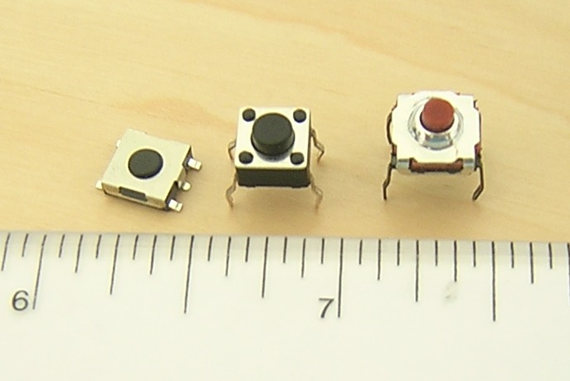

A switch may be directly manipulated by a human as a control signal to a system, such as a computer keyboard button, or to control power flow in a circuit, such as a light switch. Automatically-operated switches can be used to control the motions of machines, for example, to indicate that a garage door has reached its full open position or that a machine tool is in a position to accept another workpiece. Switches may be operated by process variables such as pressure, temperature, flow, current, voltage, and force, acting as sensors in a process and used to automatically control a system.

SOURCE CODE IN ASSEMBLY

$mod51
again_inc equ 76h
length equ 7dh
key equ p0
lcd equ p1
rs equ p3.0
rw equ p3.1
en equ p3.2
sda equ p3.3
scl equ p3.4
org 0h
mov r1,#40h
mov length,#0h
mov 7fh,#0h
setb sda
setb scl
mov r7,#03h
mov r0,#60h
mov dptr,#k16
go6:
clr a
movc a,@a+dptr
mov r6,a
jz go9
sjmp ui
qp:
inc dptr
inc r7
sjmp go6
ui:
acall start
mov a,#10100000b
acall start
acall iic_write
mov a,r7 ;location from 03 to 07.
acall iic_write
mov a,r6
inc length
mov 71h,length
acall iic_write
acall stop
acall ja
sjmp qp
go9:
mov key,#0fh
go:
mov a,key
anl a,#0fh
mov r1,a
cjne a,#0fh,go1
sjmp go

go1:
mov key,#1fh
mov a,key
anl a,#0fh
cjne a,01,row1

mov key,#2fh
mov a,key
anl a,#0fh
cjne a,01,row2

mov key,#4fh
mov a,key
anl a,#0fh
cjne a,01,row3

mov key,#8fh
mov a,key
anl a,#0fh
cjne a,01,row4

row1:
mov a,r1
jnb acc.0,l1
jnb acc.1,l2
jnb acc.2,l3
jnb acc.3,l4
row2:
mov a,r1
jnb acc.0,m1
jnb acc.1,m2
jnb acc.2,m3
jnb acc.3,m4
row3:
mov a,r1
jnb acc.0,n1
jnb acc.1,n2
jnb acc.2,n3
jnb acc.3,n4
row4:
mov a,r1
jnb acc.0,k1
jnb acc.1,k2
jnb acc.2,k3
jnb acc.3,k4

l1:mov 77h,#'1'
ajmp g9
l2:mov 77h,#'2'
ajmp g9
l3:mov 77h,#'3'
ajmp g9
l4:mov 77h,#'4'
ajmp g9
m1:mov 77h,#'5'
ajmp g9
m2:mov 77h,#'6'
ajmp g9
m3:mov 77h,#'7'
ajmp g9
m4:mov 77h,#'8'
ajmp g9
n1:mov 77h,#'9'
ajmp g9
n2:mov 77h,#'0'
ajmp g9
n3:mov 77h,#'a'
ajmp g9
n4:mov 77h,#'b'
ajmp g9
k1:
inc 7fh
mov dptr,#k7
acall display
acall delay
mov a,#0c0h
acall cmd
ajmp go9

k2:
mov dptr,#k11
acall display
acall delay
acall delay
acall delay
mov a,#01h
acall cmd
mov dptr,#k12
acall display
inc 7fh
mov length,71h
mov a,length
add a,r7
mov r7,a
inc 74h
mov a,#0c0h
acall cmd
ajmp go9

k3:
ajmp aooab

k4:
mov a,#07h
acall cmd
acall delay
ajmp go9

no:
mov 7fh,#0h
ajmp go9
numb: ajmp oi
g9:
mov a,59h
cjne a,#0h,numb
mov a,7fh
cjne a,#01h,no
mov a,#'*'
acall dat
mov @r0,77h
inc r0
acall delay
djnz length,no
mov length,71h
jao:
dec r7
acall start
mov a,#10100000b
acall start
acall iic_write
mov a,r7
acall iic_write
acall start
mov a,#10100001b
acall iic_write
acall iic_read
mov 79h,a
acall delay
acall stop
mov a,79h
dec r0
mov 52h,@r0
cjne a,52h,np
djnz length,jao
ajmp aao
np:
mov a,#01h
acall cmd
mov dptr,#k5
acall display
acall delay
acall delay
acall delay
mov a,#01h
acall cmd
mov 7fh,#0h
ajmp go9
again:
mov a,#01h
acall cmd
mov dptr,#k13
acall display
mov a,#0c0h
acall cmd
mov length,71h
mov a,length
add a,r7
mov r7,a
inc again_inc
ajmp go9
abaoo:
mov a,#01h
acall cmd
mov dptr,#k14
acall display
inc 59h
ajmp go9
oi:
mov @r1,77h
inc r1
inc length
mov 71h,length
mov a,#'*'
acall dat
ajmp go9

aooab:
dec r1
fgd:
dec r1
djnz length,fgd
mov length,71h
dl:
acall start
mov a,#10100000b
acall start
acall iic_write
mov a,r7 ;location from 03 to 07.
acall iic_write
mov a,@r1
acall iic_write
acall stop
acall ja
inc r7
inc r1
djnz length,dl
mov a,#01h
acall cmd
mov dptr,#k10
acall display
mov length,71h
mov 59h,#0
mov 7fh,#0
mov again_inc,#0
mov r1,#40h
ajmp go9

;;;;;;;;;
aao:
mov a,again_inc
cjne a,#0,abaoo
mov a,74h
cjne a,#0,again
mov a,#01h
acall cmd
mov dptr,#k15
acall display
acall delay
acall delay
acall delay
mov a,#0cch
mov 51h,#81h
hi:
mov p2,a
rr a
acall del
djnz 51h,hi
mov a,#01h
acall cmd
mov 7fh,#0h
ajmp go9

display:
clr a
movc a,@a+dptr
acall dat
inc dptr
jnz display
ret

lcd_ini:
mov a,#38h
acall cmd
mov a,#01h
acall cmd
mov a,#06h
acall cmd
mov a,#0eh
acall cmd
mov a,#80h
acall cmd
ret

cmd:
mov lcd,a
clr rs
clr rw
setb en
acall del
clr en
ret
dat:
mov lcd,a
setb rs
clr rw
setb en
acall del
clr en
ret

delay:
mov r4,#0ah
d: mov r6,#0ffh
y: mov r5,#0ffh
i: djnz r5,i
djnz r6,y
djnz r4,d
ret
del:
mov 56h,#91h
o: mov 57h,#0ffh
w: djnz 57h,w
djnz 56h,o
ret

iic_write:
mov r3,#08h
i2cwrite_loop:
rlc a
mov sda,c
setb scl
acall del
clr scl
djnz r3,i2cwrite_loop
mov c,sda
setb scl
acall delay
clr scl
ret
iic_read:
mov c,sda
mov r3,#8
rlc a
i2cread_loop:
setb scl
mov c,sda
rlc a
acall del
clr scl
djnz r3,i2cread_loop
ret

ja:
mov a,#10100000b
acall start
acall iic_write
mov a,#00h
acall iic_write
acall iic_read
acall stop
ret

start:
setb sda
acall del
setb scl
acall del
clr sda
acall del
clr scl
ret

stop:
clr scl
clr sda
acall del
setb scl
acall del
setb sda
ret

k7: db 'Enter Password',0
k5: db 'Wrong Password',0
k6: db 'Ready to open',0
k10: db 'password saved',0
k11: db 'Change Password',0
k12: db 'Current Password',0
k13: db 'Password Retype',0
k14: db 'New Password',0
k15: db 'Pasword matched',0
k16: db '12345',0

end

BIBLOGRAPHY

- SEDRA SMITH

- INTRODUCTION TO 8051 MICROCONTROLLER … MAZIDI

- INTRODUCTION TO 8051 MICROCONTROLLER … AYALA

- www.wikipedia.com

